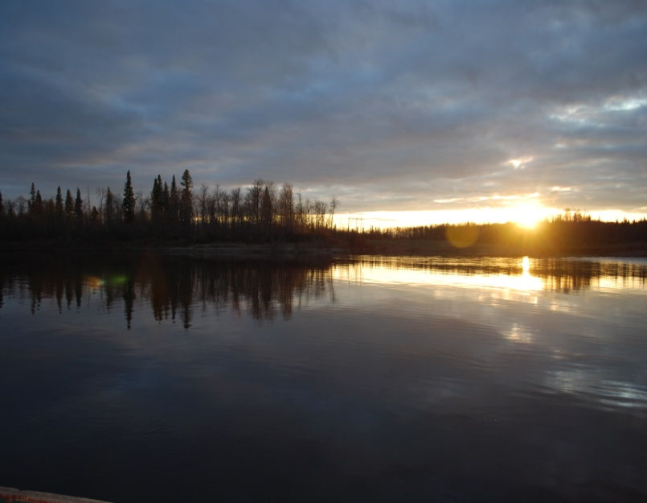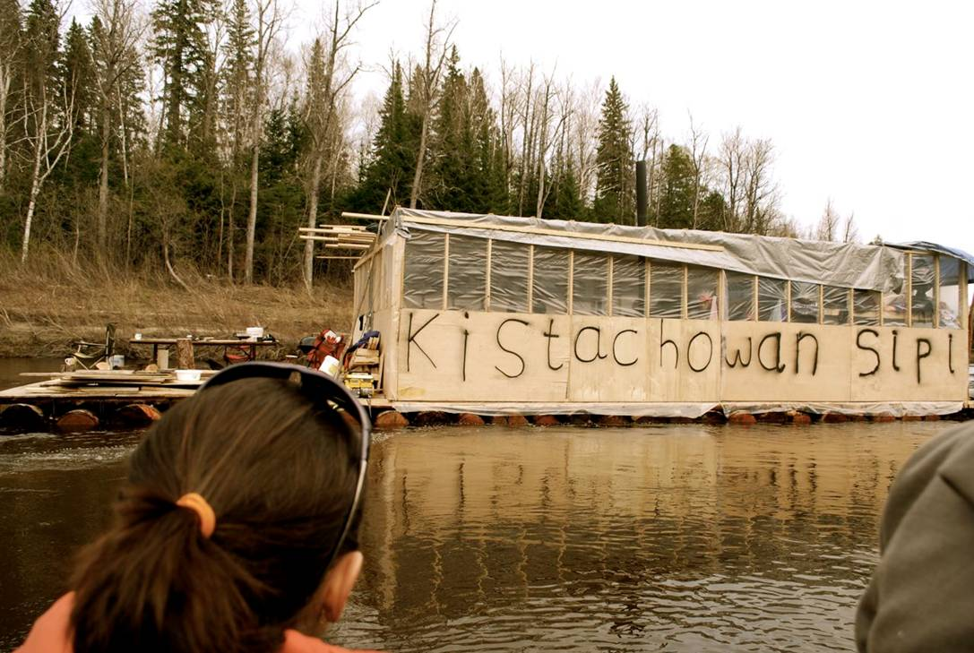

**http://paquataskamik.weebly.com/**

**Paquataskamik:**

**Knowing Traditional Territory**

Paquataskamik is the Inninowuk (Cree) word for all of nature and everything it contains. The word reminds us that Mushkegowuk Inninowuk land is vast…

…an area that ties together history, identity, and family.

**For more information, please contact:**

**Ed Metatawabin**

**Education & Outreach Coordinator (705)278-1108**

**Meshan Sutherland, Project Coordinator**

**(705)278-1076**

**Nordik Institute**

**(705)949-2301 ext.4351**

**Contact Information**

**FAFN SUPPORTING ORGANIZATIONS** COMMUNITY ADVISORY GROUP

FORT ALBANY FN OFFICE

MUNDO PEETABECK EDUCATION AUTHORITY

PEETABECK HEALTH

PEETABECK ACADEMY

ALBANY RIVER COALITION

**SUPPORTING ORGANIZATIONS**

NORDIK INSTITUTE

ALGOMA UNIVERSITY CESD PROGRAM

SOCIAL ECONOMY CENTRE

OISE/UT

MUSHKEGOWUK EDUCATION AND TRAINING

ONTARIO MINISTRY OF NATURAL RESOURCES

AND MANY MORE

The Paquataskamik Project

is a community-based research and learning initiative aimed at fostering inter-generational dialogue and understanding the importance of traditional territory to social, cultural and economic well-being.

The project involves the ongoing development of a community process bringing together youth, adults, and elders.

The Paquataskamik Project is based in Fort Albany First Nation.

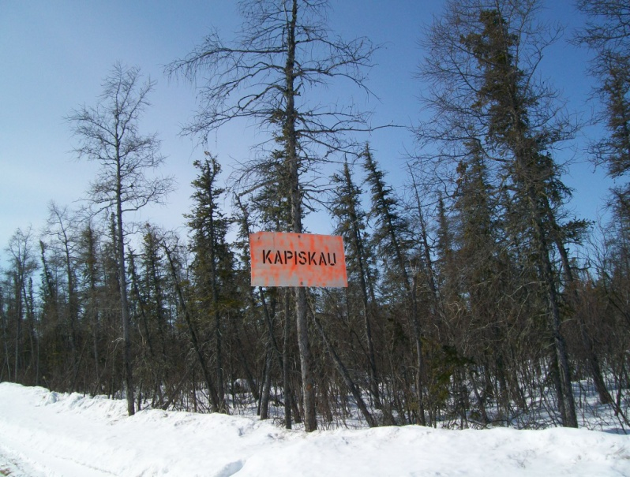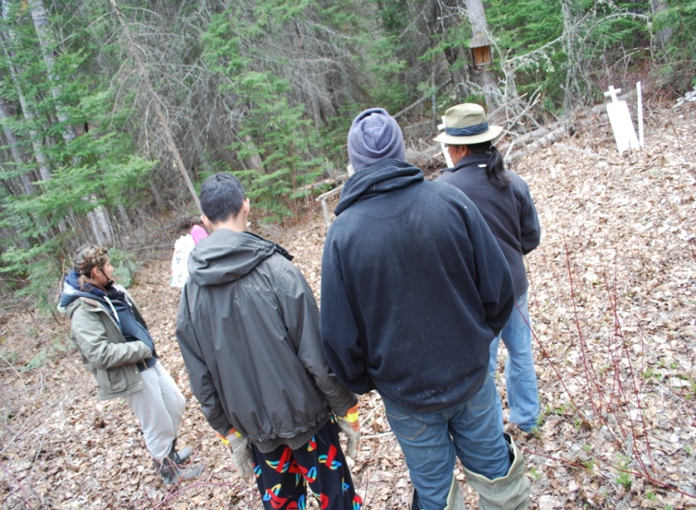

**The Paquataskamik Project centers on applied activities including:**

**➢ Community engagement and open discussion on key land issues**

**➢ Community mapping of sites and stories related to traditional territory**

**➢ High school and University accreditation in community research methods and traditional knowledge**

**➢ Land-based activities and excursions, including the 2009 Kistachowan Sipi Raft Trip and 2010 Kapiskau River Winter Excursion**

**➢ Audio and video documentation**

**➢ Production of creative materials - documentaries, website, ‘zine, written material**

**➢ Participation in events, workshops, and conferences**

**Project is ongoing.**

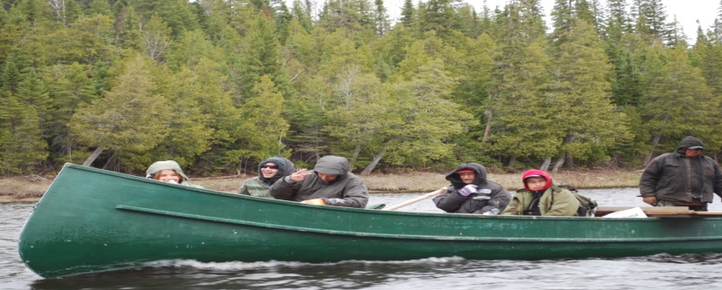

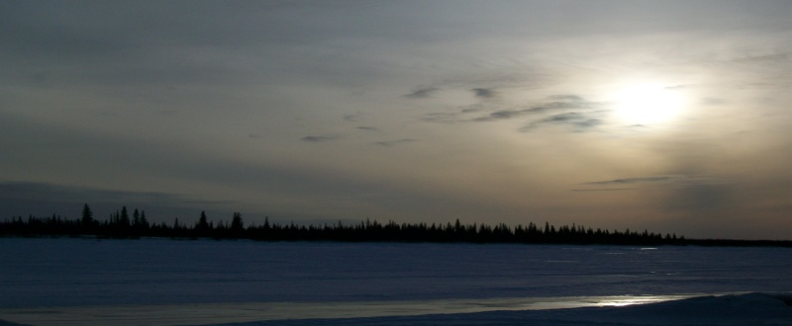

**KISTACHOWAN SIPI RIVER EXCURSION 2009**

**KAPISKAU REGION WINTER EXCURSION 2010**



In the summer of 2009, a group of youth, adults and elders embarked upon a raft trip on the Kistachowan River. Participants recorded stories, re-introduced Cree names onto a map and erected signs marking important sites – making it known to all who travel there that the region is of great significance to the original peoples of the area.

**KISTACHOWAN**

**KAPISKAU**

March of 2010, a group of youth, adults and elders traveled by snow machine to the Kapiskau River along the coast of James Bay, and further inland, taking steps in mapping sites and recording stories of traditional territory and trapping grounds.